Follow this General Format
Kite Location:
Skill Level:
Wind Direction:
Season:

SEA Assessment:

Spot:

Launching / Landing Areas
Bail Options
Hazards
Shallow Water Availability
Rescue Response Time

Environment:

Wind Conditions: Wind Speeds, Direction, Gusts
Water Conditions: Currents, Tides, and Waves

Other Environmental Factors:

i.e. like Algal growth, duckweed, wildlife restricted areas, etc

Activity:

Beach goers, swimmers, watercrafts and additional water activities that impact safety.

Resources:

Note: The rating system for IKO is low risk, moderate risk, and high risk.

Kite Location: Golden Gardens
Skill Level: Independent / Advanced
Wind Direction: N, NNW, NNE
Season: Year Round Wind

Spot:
Golden Gardens is a charming location that typically offers clear skies on breezy days, with the Olympic mountains providing a beautiful backdrop. It is a popular spot for beach enthusiasts, so it's usually crowded except in winter. GG is a year-round location, with generally lighter winds during the summer ideal for foiling, but there are occasional days suitable for TT. The stronger wind days are usually seen in the Fall, late winter, and early spring. Riders should have a good grasp of transitioning, body dragging, riding upwind, relaunching in light wind, and performing quick self-rescues before attempting this spot. Due to the high number of beach visitors and turbulent winds near the launch area, this spot is better suited for intermediate to advanced riders. It's wise to consult with other kiters before getting started.
Rigging and Launching:
Due to the high number of beach visitors, the common launch area is a small space at the north end of the beach. While there is room for several kites, only one launch or landing is recommended at a time. Watch out for debris, thorny bushes, and a bench. This spot requires a launch-and-go approach due to wind shadowing near the launch, ground hazards, and beach users. When landing, aim to come onshore just north of the launch point.
Self Rescue and Bail Options:
Since this location has a side-shore setup, options are limited. There is a marina and a rocky jetty to the south of the beach. With heavy boat traffic in the area, it's not advisable to get stranded there or swim through the zone. To stay safe, always stay upwind of the launch, especially during landing, and be skilled in self-rescue techniques.
Hazards:
If the wind shifts slightly to the northeast, an offshore wind may develop, creating a significant wind shadow south of the launch. In such situations, it can be challenging to relaunch if the kite drops near the shore or downwind of the launch. Prompt self-rescue can prevent drifting too far south. Keep in mind that there is often a slight northeast wind component at this location. Be sure to be mindful of the pylons adjacent to the launch area, as highlighted on the accompanying Google Map. These structures can be quite difficult to spot, especially during high tide.
Environment:
Wind Conditions: Wind Speeds, Direction, Gusts:
The setup for lighter winds is usually initiated by a developing ridge of high pressure in the northwest from the North Pacific High (NPH). Stronger winds require a combination of factors: high pressure in interior BC with an inverted trough extending from Oregon into the Puget Sound area. During stronger winter conditions, high pressure forms in interior BC and pushes through the Fraser gap into the sound. Look for consensus among short-range models (TJs, HRRR, ik-WRF, UW-WRF-GFS, etc.) for wind speeds exceeding 10-15 knots. This location is safest with northerly winds primarily due to obstruction from the south. In summer, winds range between 10-15 knots, occasionally reaching around 20 knots in stronger setups. Winter winds typically range from 15-20 knots, with stronger conditions exceeding approximately 25 knots. This spot is ideal for Foils, but Twin Tips can also be used on many days.
Water Conditions: Currents, Tides, and Waves:
GG can be navigated at any tide, with a lowering tide being preferable. A rising tide may create a strong current, making it challenging to maintain upwind direction on a TT in winds less than 15 knots. The current can reduce your apparent wind on a TT, so it's advisable to check the tide forecast beforehand. Foils are less affected by this issue. The water surface has moderate chop, with enjoyable swells forming in stronger conditions during a lowering tide.
Environmental Factors:
Sea Lions can be in the area but aren't known to bother kiters. Please give our wildlife some space while riding.
Activity:
Considering the large number of beach visitors and strong winds around the launch site, this location is more suitable for intermediate to advanced riders. It's advisable to seek advice from other kiteboarders before beginning your session.

Jetty Island, Everett
Skill Level: Learner Friendly
Wind Direction: NW
Season: Spring/Summer (June – August)

SEA Assessment:

Spot:

Jetty island is one of the ideal summer spots in the Puget Sound! During the months of June – August, Jetty typically blows with afternoon NW thermals beginning between 2-7 pm and can last anywhere from an hour to several hours into the dark. It is a light side-onshore wind so kiters are usually on 14-18m kites, although a few days in the season it may blow to allow for 12m. Smaller riders > 150 lbs (68 kg) will usually be on 12m kites.

Environment:

Season:

Jetty Island is, in a word, steady! During the months of June – August, Jetty typically blows with afternoon NW thermals beginning between 2-7 pm and can last anywhere from an hour to several hours into the dark. It is a light side-onshore wind so kiters are usually on 14-18m kites, although a few days in the season it may blow 12m. Smaller riders will usually be on 12m kites.

Wind Conditions:

Jetty Island sits in Port Gardner bay which, due to the inlet of the Snohomish River, is a large tidal flat. On low tides there are literally 100’s of yards of beach between the island and the water’s edge. This flat bottom contour creates very smooth water and nice peeling waves on low tides. Common water conditions at Jetty can be very flat on the lighter 16m days and, depending on the tide, rolling swell around 3 feet as the wind picks up. Because the water is so shallow here the temperature is several degrees warmer than the rest of the Sound. On a tide 9 ft and below there will be waist deep water for a long way out and it can heat up to almost 75 degrees on an incoming tide. Some kiters ride with only shorts, but at least a shorty is recommended as the outer waters

Other Environmental Factors:

Activity:

In the summer Jetty becomes a very busy beach full of kiters and beachgoers. Please be extremely courteous to all as we do not want to lose access to this incredible location. Do not put your kite over, kite close to or kite through ANY swimmers in the water. Stay as far north as possible at all times unless you are a long way out from the beach. There is a “Kiteboarding Zone'' free-standing sign that is now in use. Please stay north of that sign. Many spectators come over to Jetty Island just to watch us kite but the majority of them are there to spend time with their children, letting them play in the sand and swim. During the summer the Everett Parks Dept hosts educational shows and events for the kids giving talks and tours of the island and its wildlife. The wind can sometimes be onshore and when the tide is high up to the logs it makes launching and landing a bit trickier. The Coast Guard and Sheriff’s Dept are vigilant about preventing drownings. Your watercraft is likely to be inspected. The river crossing to Jetty is cold and deep and the current can be swift. It is the law for kayakers to have and wear their life jackets ($100 fine). Free loaner jackets are available on the north end of the launch. A whistle is also required as is a light for night kayaking. Dogs are not allowed on the island because it is a bird refuge and alcohol is strictly prohibited with a $1000 fine. Be aware that Jetty has no shade or shelter so bring plenty of water and wear sunscreen. Help keep Jetty Island clean! Please use the trash cans.

Resources:

TJ's forecast (highly reliable but consistently about 5 kt low, updated several times a day):
Look for pink or better (9+ kt) through the straights and reaching Jetty Island. 12+ is a solid forecast.
http://wxtofly.net/loopallbasic.html?param=tenmwind&region=PNW&grid=d2

NOAA Marine Forecast (15-20+ kt in East Entrance U.S. Waters Strait Of Juan De Fuca and Admiralty Inlet):
https://www.urbansurf.com/weather?beach=JI&surf=WA

Jetty Island buoy sensor (paid, limited free features, formerly Steamboat Flats): http://wx.ikitesurf.com/en-us/Search/ViewResults.aspx#48.011,-122.202,13,3,93974,1

Jetty Island sensor (free, community supported, seasonal, usually lower readings than the paid sensor):
https://www.wunderground.com/personal-weather-station/dashboard?ID=KWAEVERE78

Extra sensors:

Watch for the Pt Wilson, Hat Island and Point No Point sensors to be NW and the Keystone – Pt Townsend ferry readings to be NW 15 or greater.

Pressure gradients (Look for Port Angeles - Seattle, current temp +10 F, current pressure gradients NW 0.03" or better):
http://nwwind.net/wind.php?region=3&sdate=2017-05-10

Also, watch for a pressure gradient of about .10 west or larger between Seattle and Wenatchee.

Notes:

A decent example of what to look for (at Jetty specifically) when using the gradients page and a good chance to nerd out a bit: http://allthingsstructured.com/gradients You can see that the Everett-Port Angeles pressure gradient was stable at .01W before bumping up to .02W around 6 (when the wind started to pick up). This is reinforced by the (fairly large) temp gradient and quick ramp up between updates. It also helps that the SEA to PA gradients follow a similar pattern. Why does that help indicate wind? High pressure likes to move toward low pressure and colder air is generally denser than warmer air. So, when you have cooler and denser air west at PA and warmer less dense air at Jetty, it's a good sign for wind. The faster that change happens, the better. What are the magic numbers to make it go? There is no magic unfortunately! There are decently reliable patterns when taken in context, however. Assuming a day like yesterday (few clouds by noon, temps in the ~70s, decent numerical model forecast), I've generally found that on .02W Everett-PA usually requires a bigger temperature gradient to boost it (~7+). When the pressure gradient is bigger (.03W+), the temperature gradient can be smaller (~4-7).

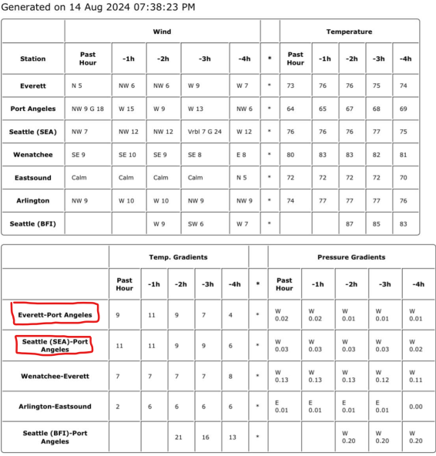
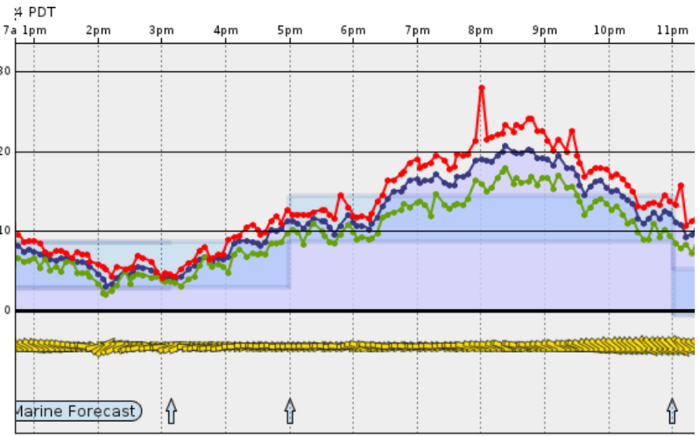

Squamish, BC
Skill Level: Learner Friendly
Wind Direction: S, SW
Season: May - September

Spot:
The Squamish Spit is best suited for independent riders who can stay upwind, ride among others, and perform a self-rescue in deep water. This location is considered learner friendly because there are kite schools and local staff available with assisted watercrafts. For those who lack confidence in their skills, Squamish Water Sports offers lessons and refresher courses. The sandbar emerges at tides below 5 feet, offering plenty of shallow water. When launching and landing at low tide, it's convenient on the sandbar with ample space for preparing lines and less crowded. However, access to the sandbar is limited as the tide rises quickly. During high tide, the island is busy, making launching and landing more challenging, but staff on the island are available to help. Kites take turns for launching and landing smoothly requiring some patience. Kiting from the new park and beach is currently not allowed due to a recent incident under investigation. Winging in the new area is ideal as you can utilize the new grassy area for setup directly from the beach, eliminating the need for a boat shuttle.
Rescue Response:
The Squamish Waterspots Society is equipped with jet skis for emergency situations. Their staff members have sea-doos with rescue sleds, ready to help individuals in distress on the water. It is important to note that this retrieval service may not always be available, as the team could be occupied or unable to spot you. Beginners who struggle to stay upwind should not rely on frequent shuttle services. Such aid is typically provided by kite schools for their students.
Environment:
Wind Conditions: Wind Speeds, Direction, Gusts:
The wind conditions are favorable from May to September, with July and August typically experiencing windy days almost 100% of the time. While the wind speed may seem intense when walking on land with your kite, once on the water, the current can reduce the apparent wind so consider a larger kite size than usual to compensate for these conditions.
Water Conditions: Currents, Tides, and Waves:
The water is notably cold, requiring the use of a wetsuit even on a warm, sunny day. Originating from mountain snowmelt, the water is colder compared to other areas in the PNW region. It's crucial to be ready for extended time in the water, even when the weather is nice, so wearing 5/4 to 4/3 wetsuits and booties is recommended. Booties are also advisable due to the rocky shores for launching, landing your kite, and accessing the island/spit. During low tide, the water can be choppy, but it smoothes as the tide rises. In front of the island, there is a flat water area that gets lively with experienced riders performing jumps and tricks. While open to all, it's important to take turns and allow space for others to showcase their skills.
Being able to ride upwind is essential due to the current. The low tide window is short, and the tide rises swiftly, causing a rapid increase in water depth.
Other Environmental Factors:
North of our windsports area lies a vast wildlife management area, which serves as a delicate natural habitat. Kindly maintain a distance and show respect to the wildlife in that area. Feel free to inquire with the staff or refer to the map to identify the boundaries.
Activity:
The spit is usually quiet during weekdays. On summer weekends, it might get crowded on the spit, but skilled kiteboarders who set up their lines efficiently and launch properly face no issues. Moreover, there is ample space on the water for everyone.
Resources:
Squamish Windsports Society https://squamishwindsports.com/
Live Webcam (usually up daily at noon). Check it out, super cool views of the tides, the spit and kiteboarders doing tricks.
Free parking, boat shuttle info and schedule.
Boat Shuttle to the island (40$ per day)
Kite launch and land support on the spit

Damon Point, Ocean Shores
Skill Level: Learner Friendly
Wind Direction: NE, E, ESE
Season: Winter

Details:
Great for winter kiting on NE, E and ESE winds on the inside of the bay at the southeast part of the Ocean Shores peninsula. It’s a beginner friendly spot on mid to low tide with long sandy beach though be careful with on-shore winds. High tide increases launching/landing hazards: due to no beach watch for rocks, logs, bushes & proximity of the rock jetty. Most of the time it’s a smooth wind and fairly flat water kiting. If the wind turns too southerly it gets holey and gusty on the inside. Walk over to the south shore of the peninsula for kiting some waves on southerly winds. (Waves aren’t for beginners though.)

It blows primarily early in the morning and dies off early afternoon though on occasion it’s windy all day long. If Tatoosh Is and Columbia River Bar sensors on iKitesurf show easterly in high teens or better and Hoquiam sensor registers east in low teens you are likely to get 20+ mph wind at Damon. Grays Harbor Shore Conditions Information Line (360 268 1444) would give you most accurate update, but unfortunately tide and weather information is currently unavailable. All-n-all it’s a fun place with a bathroom at the parking lot to change out of the wind.

The campground right there has a boat launch and easy walk to the kite launch areas. Great for RV with hookups, not very nice for tenting. It rarely fills up except summer holiday weekends. Almost deserted any time but summer.

Facilities:
The bathroom with showers at the site is NOT a public restroom. It is for the private campground and is maintained by the owner. However, we are on good terms with the owner (his name is Tom). Watching kiteboarders is great entertainment for his guests. If you do need/want to use the restroom, please hose off sand with the outside hose at the office building. Introduce yourself to Tom. Always be courteous. Frequent DP riders have asked that we do a little more and drop a few $$ at the office drop box.

Directions from Seattle (Approximate driving time: 2.5 hours)

1. Head South on I-5 to Olympia
2. At Olympia take Exit 104 (towards Aberdeen & Ocean beaches) Hwy. 101 North
3. Stay on main highway. It turns into Hwy. 8 West. Then, at Elma, it changes into Hwy. 12 West
4. Upon reaching Aberdeen, follow the signs that take you to Hwy. 101 North - to Hoquiam and Ocean beaches. DO NOT TAKE THE WESTPORT TURN
5. You should be in the left lane as you cross the Hoquiam bridge. Bear right and then turn left at the second traffic light onto Hwy. 109 (Ocean Shores and Ocean beaches)
6. After approximately 18 miles, turn left onto Hwy. 115 (Oyehut/Ocean Shores)
7. Highway 115 turns into Damon Rd. as you curve to the right. Turn left into Ocean Shores – through the stone gates.
8. Once you hit town stay on Point Brown Ave until you cross Ocean Shores and approach south end of the peninsula.
9. Point Brown Ave SE will curve right and will become Discovery Ave SE.
10. Go for approximately a quarter mile and as Discovery Ave curves right again (heading west) make a left turn onto a short road that will bring you to a parking lot.

Locust Beach, Bellingham
Skill Level: Learner Friendly
Wind Direction: SW, S, SE
Season:

Spot:

Launching / Landing Areas

below 4' tides you can launch off the tide flats, which is fine sand/silt, messy but rinses right off
Above 6-7', there is a strip of sand that you can self launch off but the strip of big rocks between the tide flats and can catch your lines, having someone to help is good. When the tide is 8' + the water is almost up to the trees. There are pilings that you can tie your leash to for Bow self launches or using a 5th line to self launch off the water

Bail Options
Hazards
Shallow Water Availability
Rescue Response Time

Environment:

Wind Conditions: Wind Speeds, Direction, Gusts

Wind at Locust can vary from gentle summer thermals to gusty winter storm winds.

Water Conditions: Currents, Tides, and Waves

Best in tides less than 6’. Tides above 6’ make the beach small and hazardous. nLaunch with kite in the water at higher tides. Image above shows the beach at a 5’ tide. Very low tides can sometimes create a mile walk to the water. Lower tides can be great with a 2+ mile slick of butter smooth water. When the tide is really low either just ride in the narrow strip of the Nooksack River cutting thru the flats or head upwind to deeper water. Summer can also have bathtub warm water on low tide days. Never the same, usually a good time when there's wind. When it's low the walk to the water can be pretty far so check out Squalicum Beach or Post Point. Great spot for learning to kite board. Except at high tide. Then it's tough. The water temperature can vary from 48 degrees near the river mouth to nearly 80 degrees in summer in the flats at low tide. At low tide the water is very shallow for miles. Some logs and sticks appear from time to time. The bottom is sandy for most of the bay.

Other Environmental Factors:

i.e. like Algal growth, duckweed, wildlife restricted areas, etc

Activity:

Beach goers, swimmers, watercrafts and additional water activities that impact safety.

Super long reaches, no boat traffic, usually you can stand up anywhere so it's great for trying new stuff and crashing your kite, easy to get it relaunched and lines sorted without swimming in or bailing on your sesh. Locust beach can be crowded and busy on a good day. Be considerate of non-kiters.

Resources:

Parking:

Parking/Access: Park along shoulder before train trestle, a few hundred yard down the public shore trail to the beach

https://drive.google.com/file/d/1c1mQMC1GY5ITA644wrWy5y1qUghSy9xZ/view?fbclid=IwAR1qvOXlr9uSwYX8J6FZ9Gg4l814DJtV_fBpvqIRANPG7FNjg0QajA3PJvs

Bayview State Park
Skill Level: Learner Friendly
Wind Direction: NW
Season:

Bayview is probably one of my favorite spots for its simplicity. Works best on NW wind (I'll spare the details of the setups, but tomorrow has potential to watch). You park in the yellow area and launch in the red area. Super simple. The bay empties out on lower tides so the water can get shallow. Directions: https://maps.app.goo.gl/XdS8gfEzyVAMQi217 On lower tides more of the bay is exposed and so it becomes quite beginner friendly, on mid and high tides you should at least be able to hold your line to avoid being blown downwind.

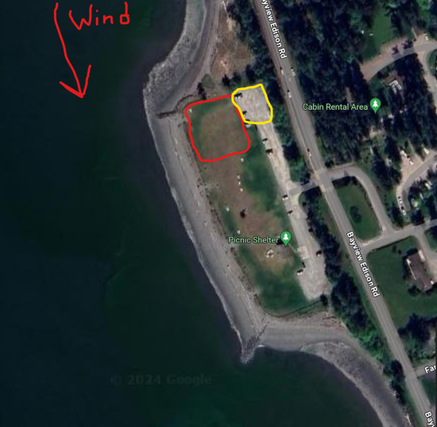

Keech

You can use this sensor for Keech for reference. It's pretty accurate but updates slowly at once an hour. Maybe a bit stronger on the water. You want the direction to be SE or slightly SSE. Too much ESE and it starts to get pretty gusty. Given it's mountain wind, it's much less stable than something like Jetty, so always be ready for gusts or big lulls. Like @MikeG said the water is quite cold. The stumps while avoidable are noteworthy and vary with water level. The beach can be rocky, so highly recommend booties even during summer. (edited)

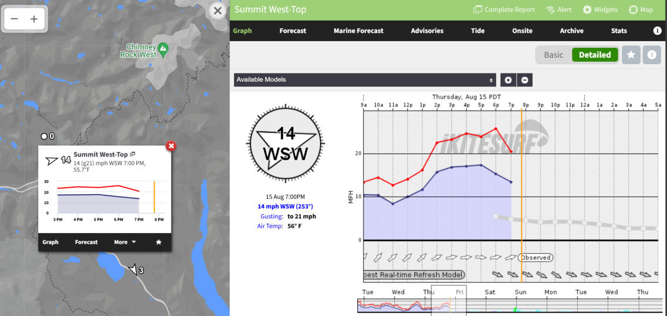

Iverson Trail Preserve

- Iverson is a spot that works on S/SSE/SE wind. SW and it’ll start to get flukey/shut down. It’s best during fall/winter/spring but if southerlies come, it’s worth considering. It’s often (but not always) a bit rain shadowed. The tide is a concern both from a launch perspective (if kayak point tide station is above ~9-10 feet the beach gets really small or totally filled and there’s floating logs. You can launch from the grassy field by the lot but then you have to walk the kite a long way (not a beginner move). If the tide is incoming swiftly, it’ll sap your apparent wind so a stronger setup is needed in those conditions. On an outgoing tide (opposing the wind), you’ll get a boost and upwind becomes super easy. Other hazards are that the launch is your reference point. Never go downwind of the launch. @Agata can explain the hike available if you do.

good to know, and will definitely take note if there is a high flooding tidal coefficient. I'm assuming that the circled spot is launch, and that we don't want to kite in the 'X'ed off bay?

Oh at super low tide occasionally the spot starts looking like a river network since the water drains out almost completely

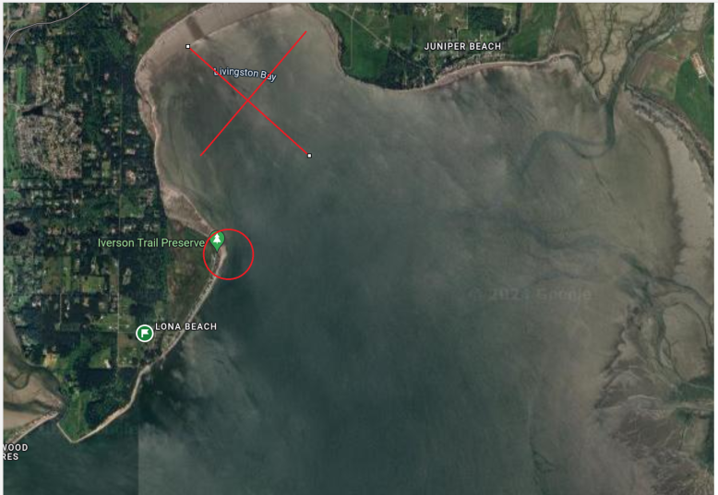
Here’s a few more details. Also, please be respectful of the locals when driving down the street. Stoke levels are always high but keep it below 25. You can use the juniper beach sensor and it’s reasonably accurate for wind.

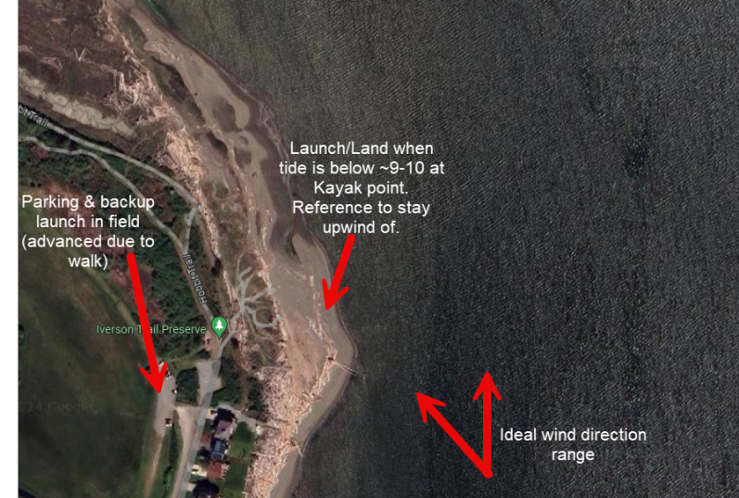
- It’s one of my favorite spots. The chop is minimal and it can be an awesome spot to practice jumps. There can be (like anywhere in the sound) logs/debris in the water so keep an eye out.

There’s some buoys to watch for but otherwise it’s a beginner friendly spot if you have the basics down. You’ll usually want gloves/booties (and I like a hood) during that time of year. Water and wind is colder! This weekend has some southerly potential, so keep eyes peeled. Very rare for strong enough southerlies this time of year at those spots.

